

**Lab No 6 Artificial Intelligence**

Name ALi hassan

ID BIT-23F-017

Class Artificial Intelligence

Data 8/12/24

Class Teacher Miss Aqsa Umar

**Task1.**

Write a Python function that takes a number as input and returns the sum of its digits.

**Code:**

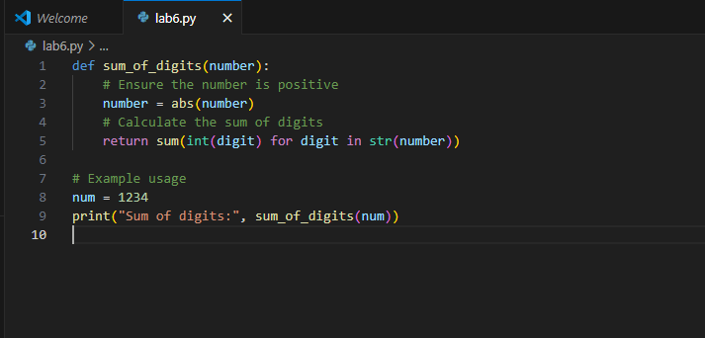

**Output:**

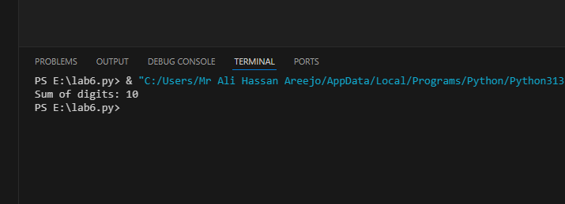

**Task 2.**

Write a Python function that takes a sentence as input and returns the number of words in it.

**Code:**

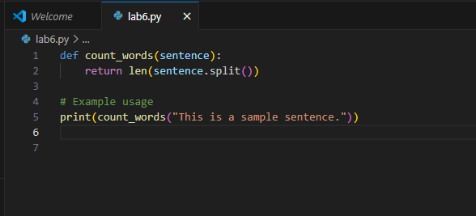

**Output:**

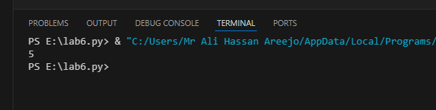

**Task 3.**

Write a Python function that takes an integer and returns whether the number is even or odd. solve this in python

**Code:**

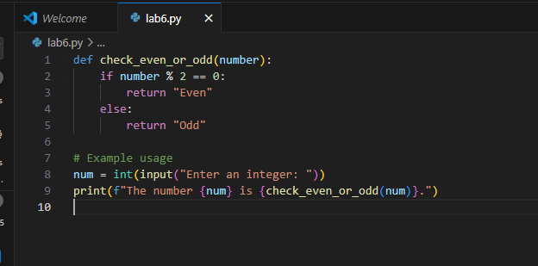

**Output:**

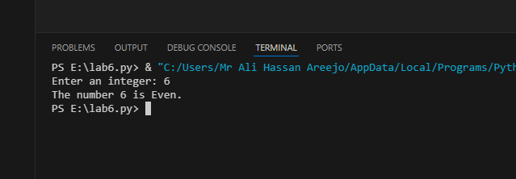

**Output:**

